**Sri Mahalakshmi Irrinki**

ASSIGNMENT 1

**Data Visualization**

**GLA Data 2**

**Date: 27th Oct 2022**

Contents

Task 1 2

**Policies and Procedures** 2

**Task 2** 3

**GDP Task** 3

1.Set a password to protect the workbook. 3

2. Highlight column C and change the data to display in British Pound symbol. 5

3. Turn the GDP sheet into a table. 6

4. Filter the table to display only the information for 2019. 8

5. Next create a chart that will only display the following data ‘Rank, Country and GDP - per capita (PPP). The chart can be anything as long as it is suitable. 8

6. Using your creative skills edit the chart 9

Add a title 9

Add X and Y axis labels Bar charts only 9

Make the chart visually pleasing 9

7. Move the chart to a new sheet tab and label with a suitable name 9

8. Create a sort for the top 20 highest ranking counties 10

9. Next create a new Bar chart to display the 20 highest ranking countries from your sort and then move the chart to be underneath the table, as shown below. 11

10. Colour the background by highlighting the area underneath the table as shown below. Find the add a fill colour icon and sellect a colour. 12

11. The next task is to create 3 macro buttons, print the sheet, Save the file and Copy the sheet. 12

Save as the document as “Excel Macro extention”. 12

12. Using the copy macro, copy the sheet and then paste it into a new word document keeping the formating. Give the page a title ‘GDP (Gross domestic product)’ . 14

13. Save your document as ‘Word Gross domestic product report 1’ 15

14. Befor we finish with our excel table ‘Gross domestic product’ sheet, we will add a headder and footer to our table. Select the ‘View’ tab from the top and find the ‘workbook views’ area, as seen below: 15

15. In the headder enter your name and GLA DATA 1 in the three boxes 16

16. In the footer add todays date then Assignment 1 and lastly Data Visualisation. 16

17. Return your view to normal 17

**Task 3** 18

**Tableau** 18

1. Import data 18

2. Set relationships: 20

3. Check data types. 21

4. Build charts 22

**Chart1:** 23

**Chart2:** 23

**Chart3:** 24

**Chart4:** 25

**Chart5:** 25

**Dashboards** 26

**Dashboard 1** 26

Link For Dashboard 1: 26

**Dashboard 2** 27

Link For Dashboard 2: 27

# Task 1

## **Policies and Procedures**

A data protection policy (DPP) is a security policy dedicated to standardizing the use, monitoring, and management of data. The main goal of this policy is to protect and secure all data consumed, managed, and stored by the organization. It is not required by law, but is commonly used to help organizations comply with data protection standards and regulations.

A data protection policy should cover the following aspects:

* Lawfulness, fairness and transparency.
* Purpose limitation
* Data minimization
* Accuracy
* Integrity and Confidential (Security)
* Accountability
* The scope of required data protection
* Data protection techniques and policies applied by relevant parties such as individuals, departments, devices, and IT environments
* Any applicable legal or compliance requirements for data protection
* The roles and responsibilities related to data protection, including data custodians and roles specifically responsible for data protection activities

In this Project we are Using ‘The Wealth of nations’ Data. It’s essential to adhere the data protection procedures and policies, because ‘The Wealth of nation’ Data is important and it is related to different nations economies. So, protecting and securing this data is our responsibility. We should adhere all the data protection policies while using this data.

As Data Analyst, I should aware of all the procedures and polices related to Data protection. Because, Data Analyst will always deals with data collection, data verification, data cleaning and data storage on different kind of data and it is essential to know all the rules and what kind of procedures need to follow while using sensitive and economic data. While secure storage media will protect data when it is not being analyzed, it is also important to follow practices that keep data secure while it is being analyzed.   Secure storage is important, but it is only one aspect of a larger set of behaviors and habits that are important when handling research data that must be kept confidential.   Ultimately, the researcher is responsible for appropriate use and storage of their research data.

# **Task 2**

## **GDP Task**

### 1.Set a password to protect the workbook.

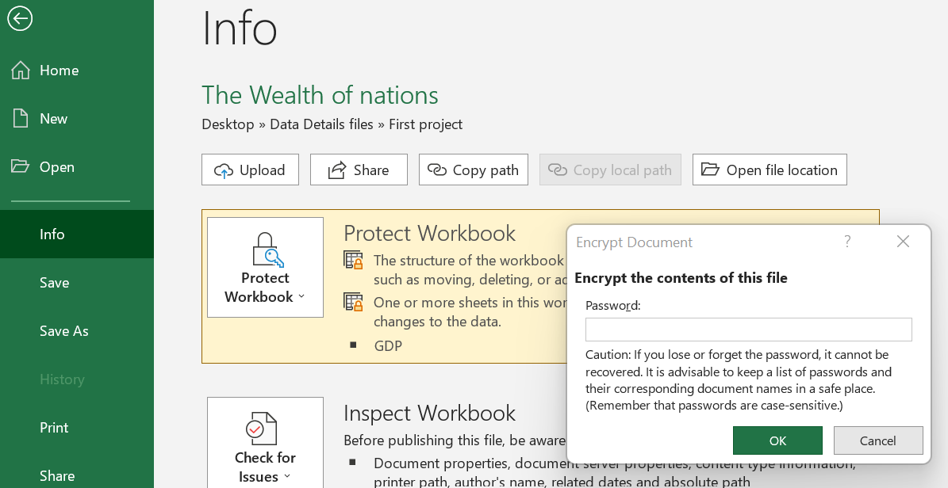

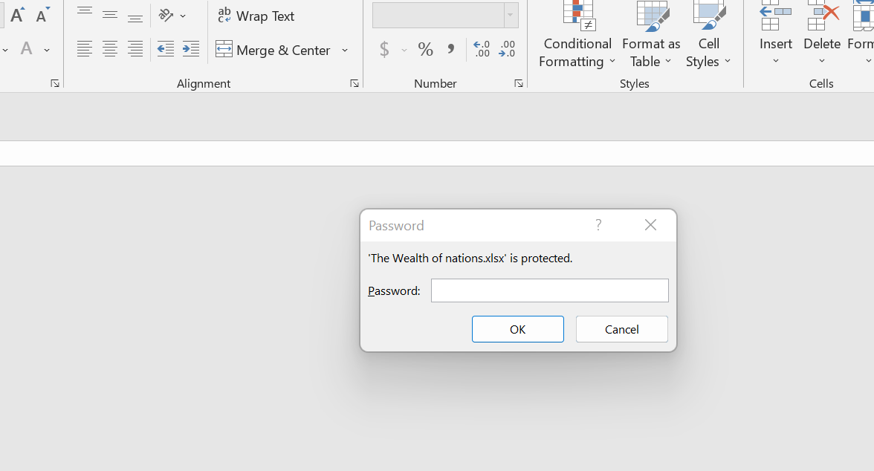

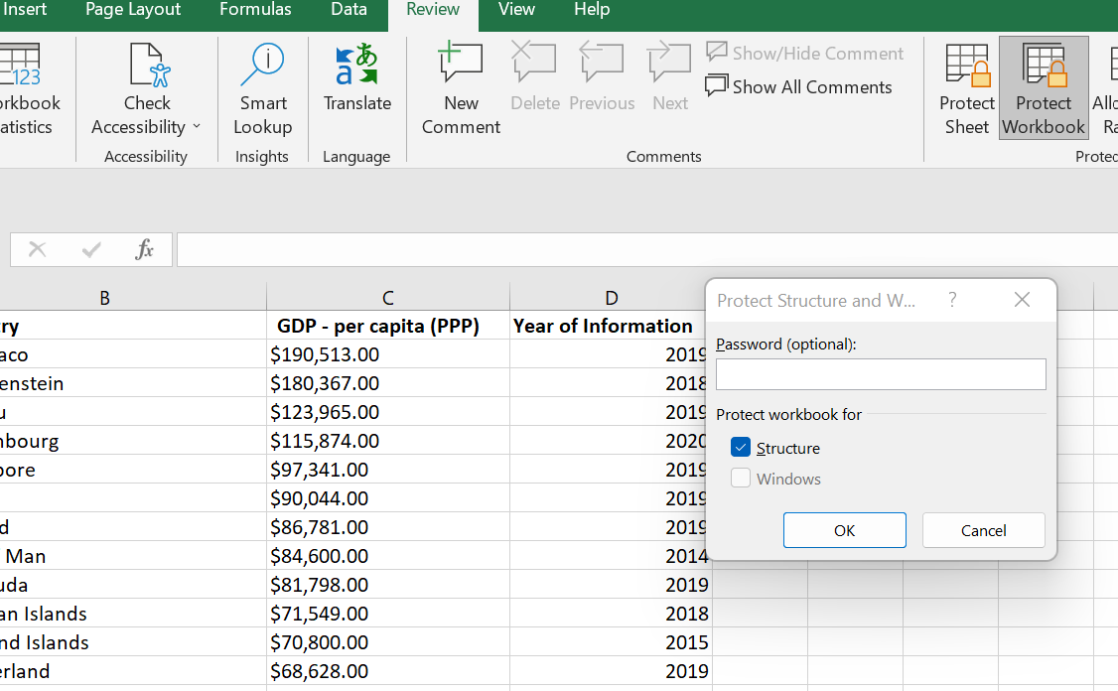

### 2. Highlight column C and change the data to display in British Pound symbol.

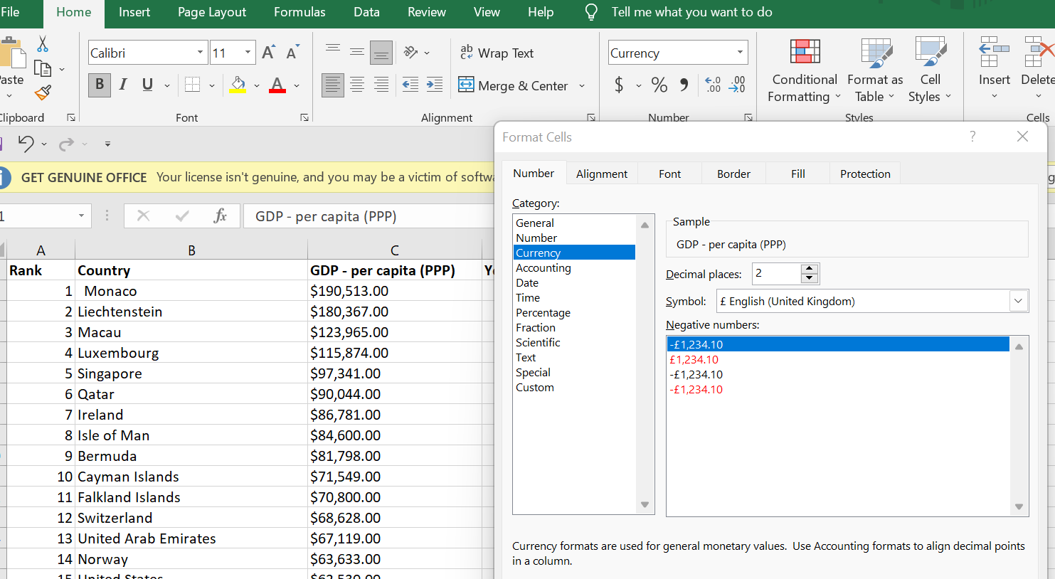

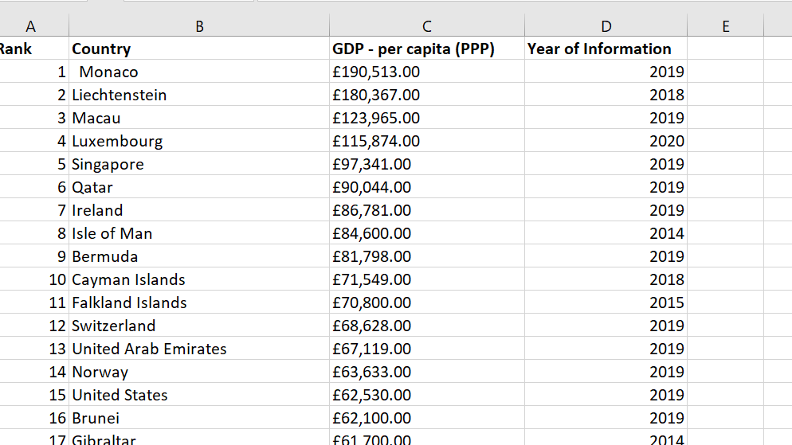

### 3. Turn the GDP sheet into a table.

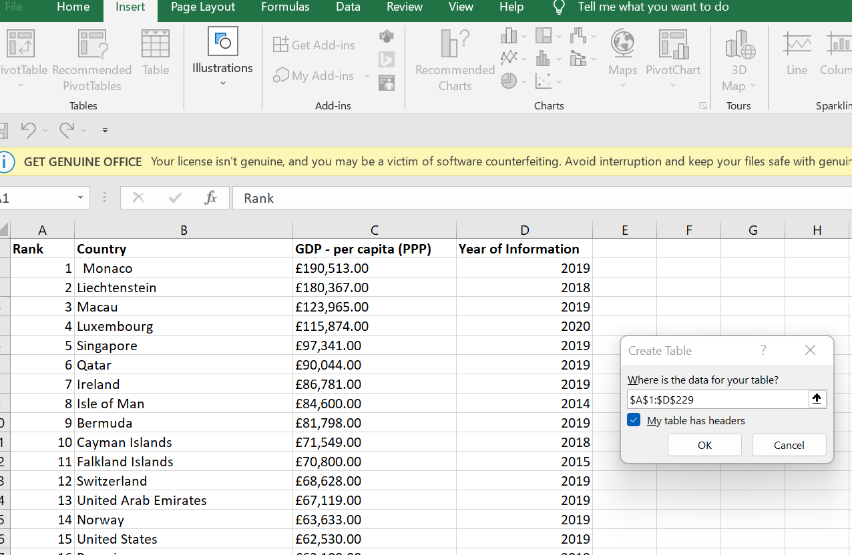

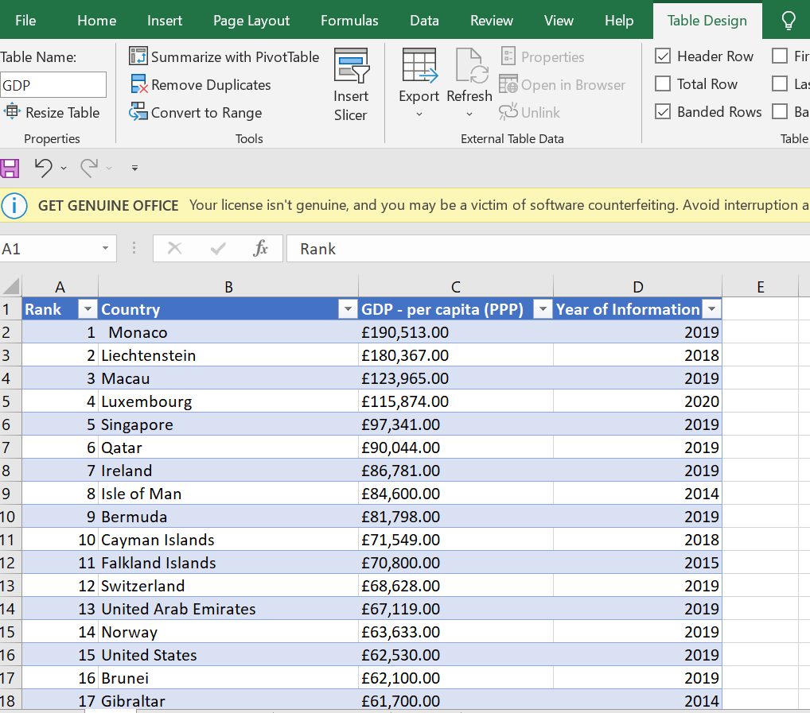

### 4. Filter the table to display only the information for 2019.

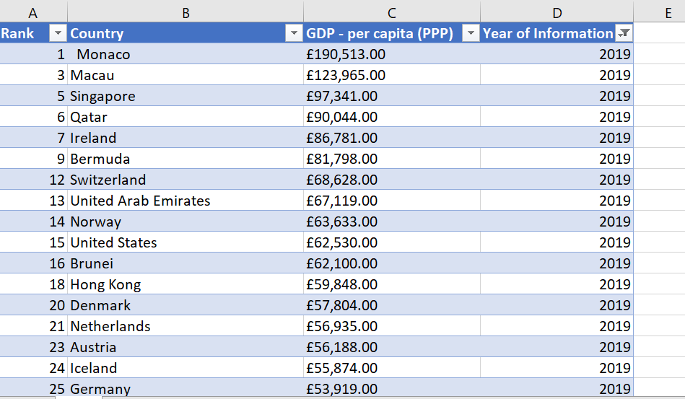

### 5. Next create a chart that will only display the following data ‘Rank, Country and GDP - per capita (PPP). The chart can be anything as long as it is suitable.

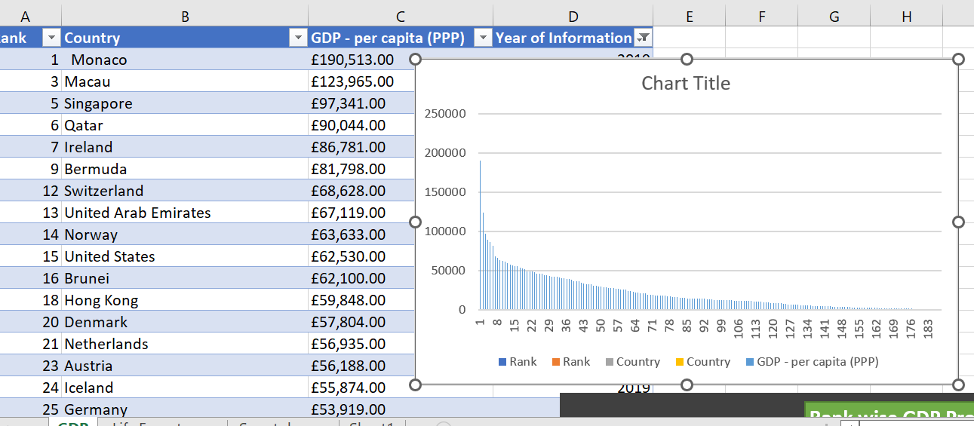

### 6. Using your creative skills edit the chart

### Add a title

### Add X and Y axis labels Bar charts only

### Make the chart visually pleasing

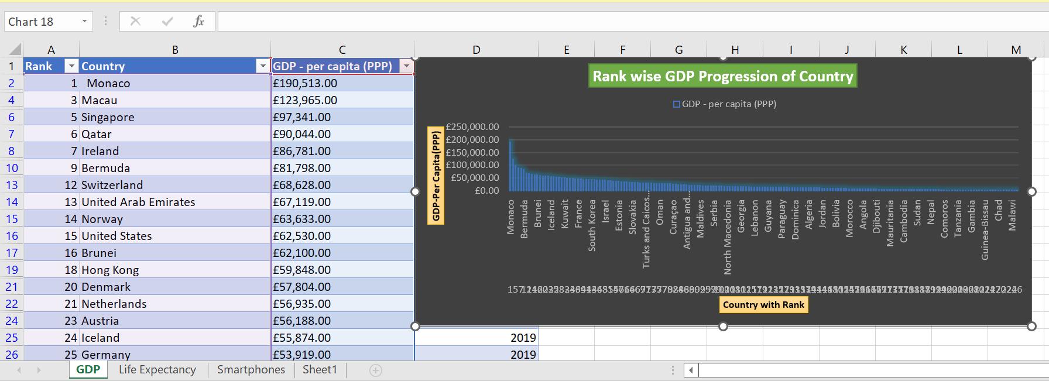

### 7. Move the chart to a new sheet tab and label with a suitable name

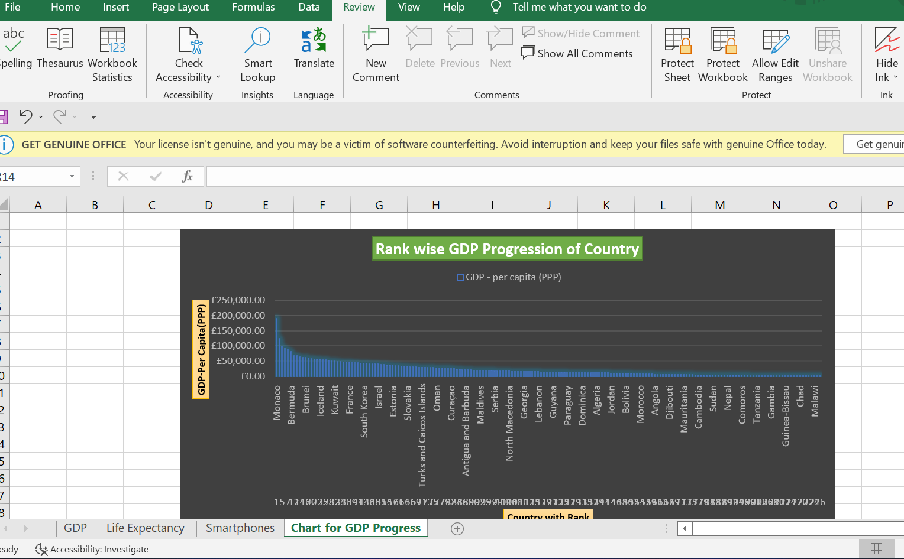

### 8. Create a sort for the top 20 highest ranking counties

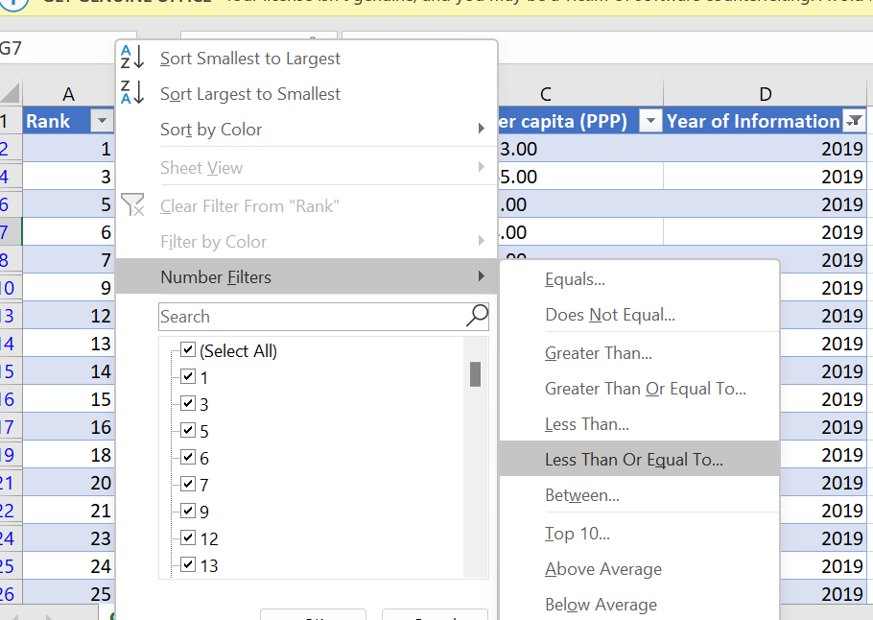

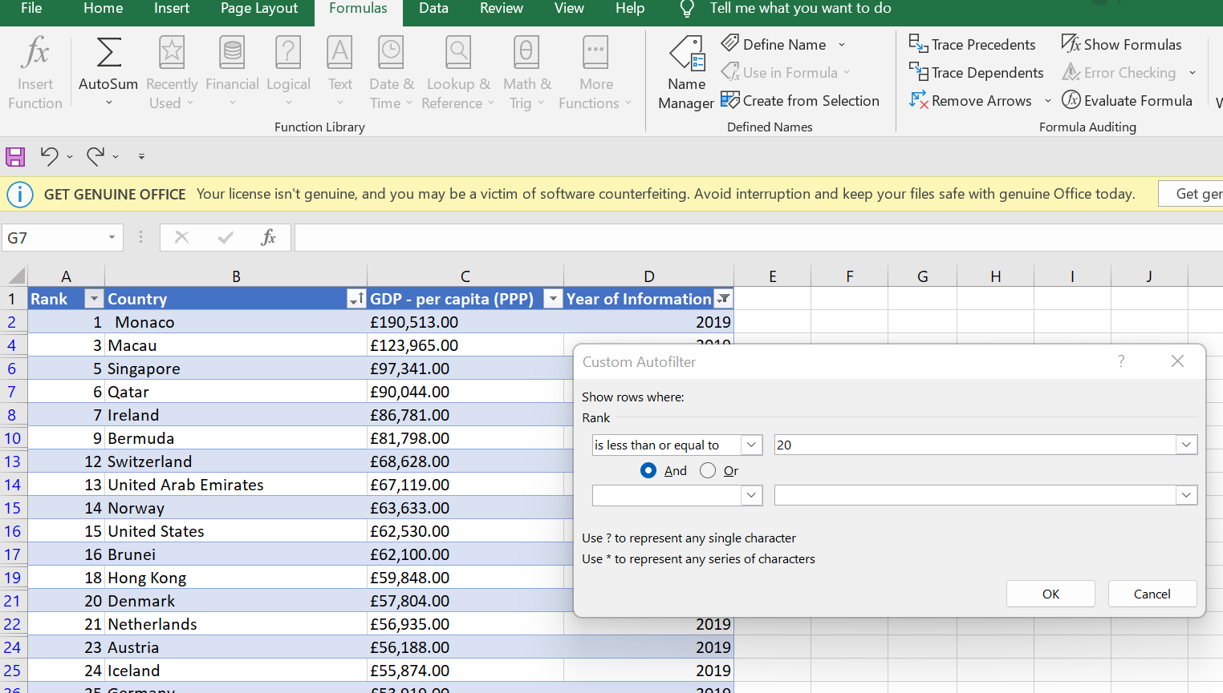

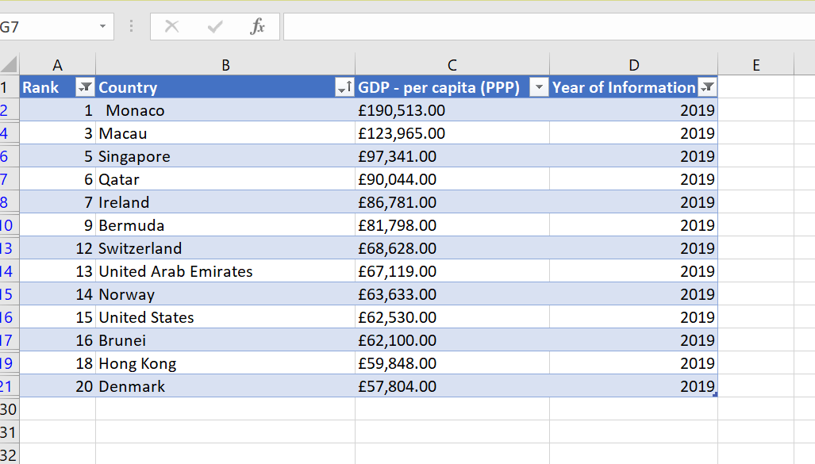

### 9. Next create a new Bar chart to display the 20 highest ranking countries from your sort and then move the chart to be underneath the table, as shown below.

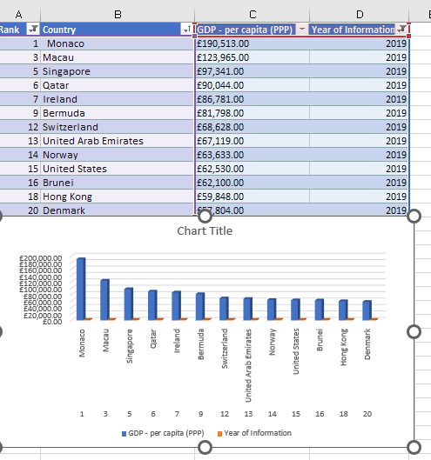

### 10. Colour the background by highlighting the area underneath the table as shown below. Find the add a fill colour icon and sellect a colour.

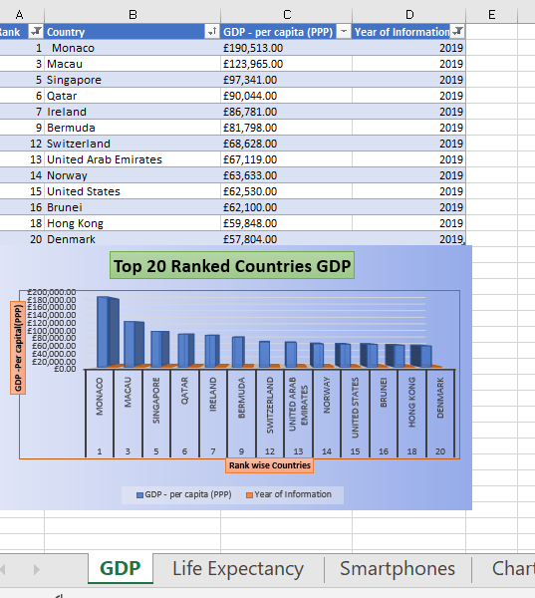

### 11. The next task is to create 3 macro buttons, print the sheet, Save the file and Copy the sheet.

### Save as the document as “Excel Macro extention”.

|  |  |  |  |  |  |
| --- | --- | --- | --- | --- | --- |
| **Rank** | **Country** | **GDP - per capita (PPP)** | **Year of Information** |  |  |
| 1 | Monaco | £190,513.00 | 2019 |  |  |
| 3 | Macau | £123,965.00 | 2019 |  |  |
| 5 | Singapore | £97,341.00 | 2019 |  |  |
| 6 | Qatar | £90,044.00 | 2019 |  |  |
| 7 | Ireland | £86,781.00 | 2019 |  |  |
| 9 | Bermuda | £81,798.00 | 2019 |  |  |
| 12 | Switzerland | £68,628.00 | 2019 |  |  |
| 13 | United Arab Emirates | £67,119.00 | 2019 |  |  |
| 14 | Norway | £63,633.00 | 2019 |  |  |
| 15 | United States | £62,530.00 | 2019 |  |  |
| 16 | Brunei | £62,100.00 | 2019 |  |  |
| 18 | Hong Kong | £59,848.00 | 2019 |  |  |
| 20 | Denmark | £57,804.00 | 2019 |  |  |
| Print  **Copy**   |  | | --- | |  | |  |  |  |  |  |
|  |  |  |  |  |  |
|  |  |  |  |  |  |
|  |  |  |  |  |  |
|  |  |  |  |  |  |
|  |  |  |  |  |  |
|  |  |  |  |  |  |
|  |  |  |  |  |  |
|  |  |  |  |  |  |
|  |  |  |  |  |  |
|  |  |  |  |  |  |
|  |  |  |  |  |  |
|  |  |  |  |  |  |
|  |  |  |  |  |  |
|  |  |  |  |  |  |
|  |  |  |  |  |  |
|  |  |  |  |  |  |
|  |  |  |  |  |  |
|  |  |  |  |  |  |
|  |  |  |  |  |  |

### 12. Using the copy macro, copy the sheet and then paste it into a new word document keeping the formating. Give the page a title ‘GDP (Gross domestic product)’ .

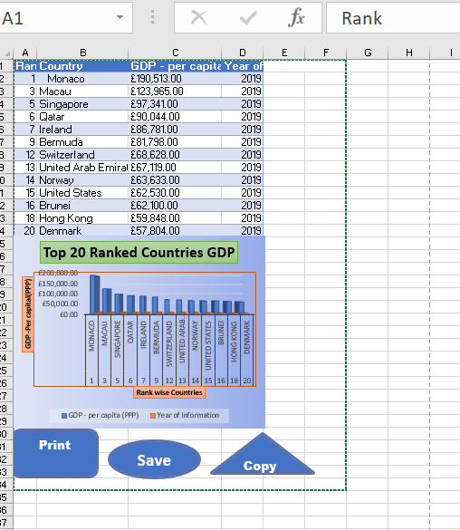

### 13. Save your document as ‘Word Gross domestic product report 1’

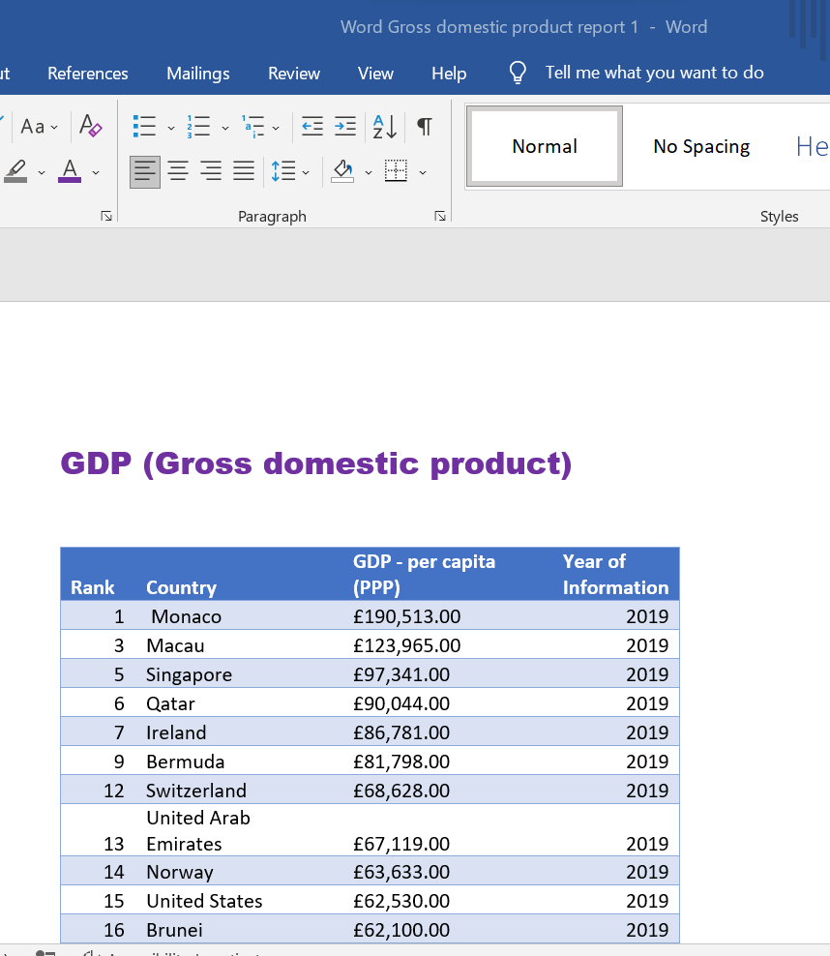

### 14. Befor we finish with our excel table ‘Gross domestic product’ sheet, we will add a headder and footer to our table. Select the ‘View’ tab from the top and find the ‘workbook views’ area, as seen below:

### 15. In the headder enter your name and GLA DATA 1 in the three boxes

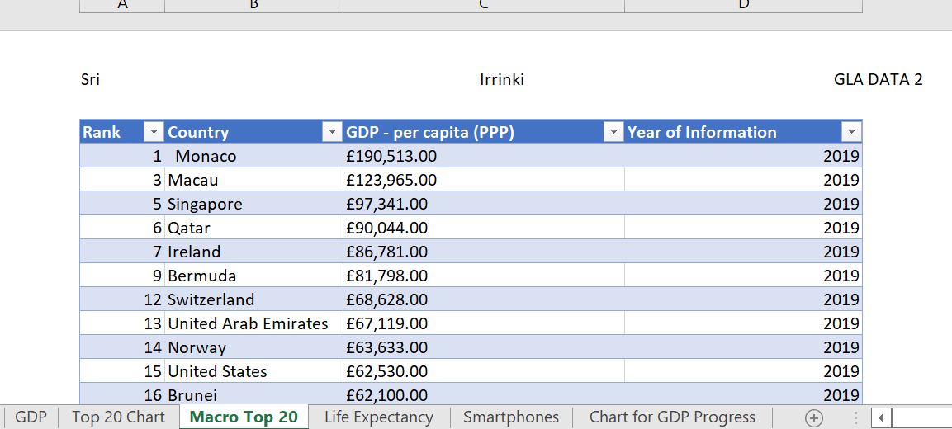

### 16. In the footer add todays date then Assignment 1 and lastly Data Visualisation.

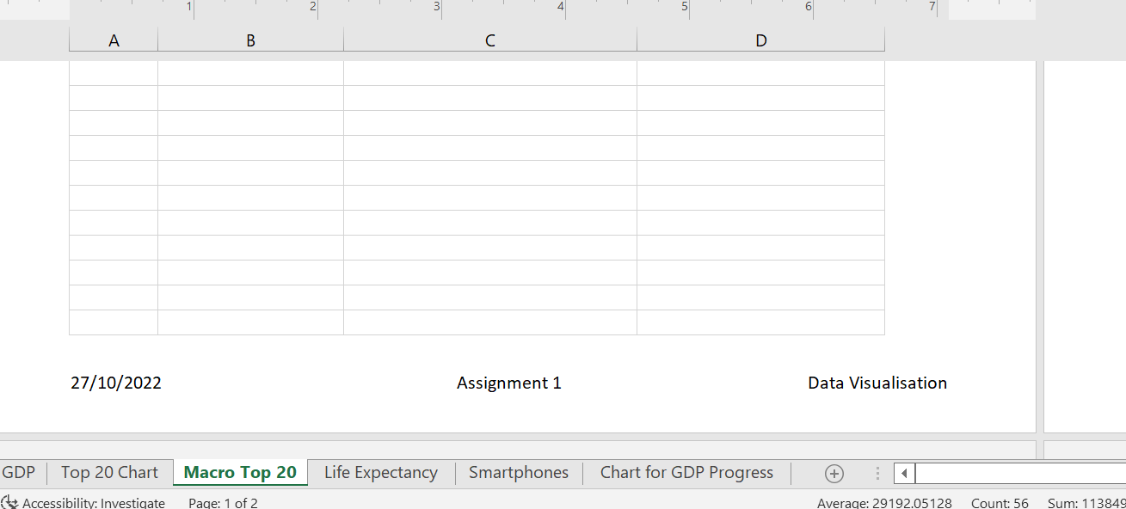

### 17. Return your view to normal

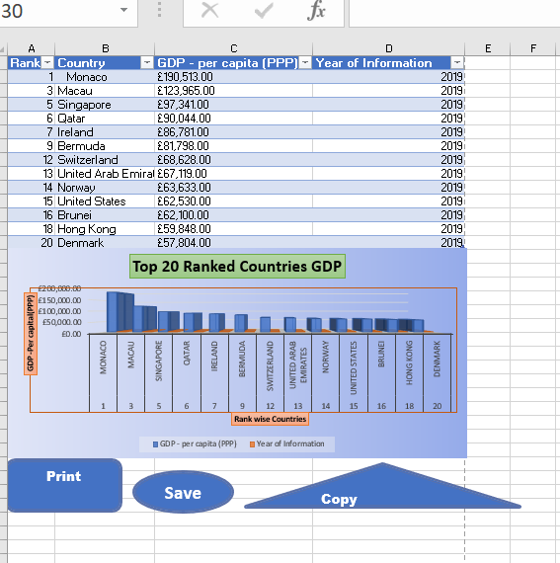

# **Task 3**

# **Tableau**

### Import data

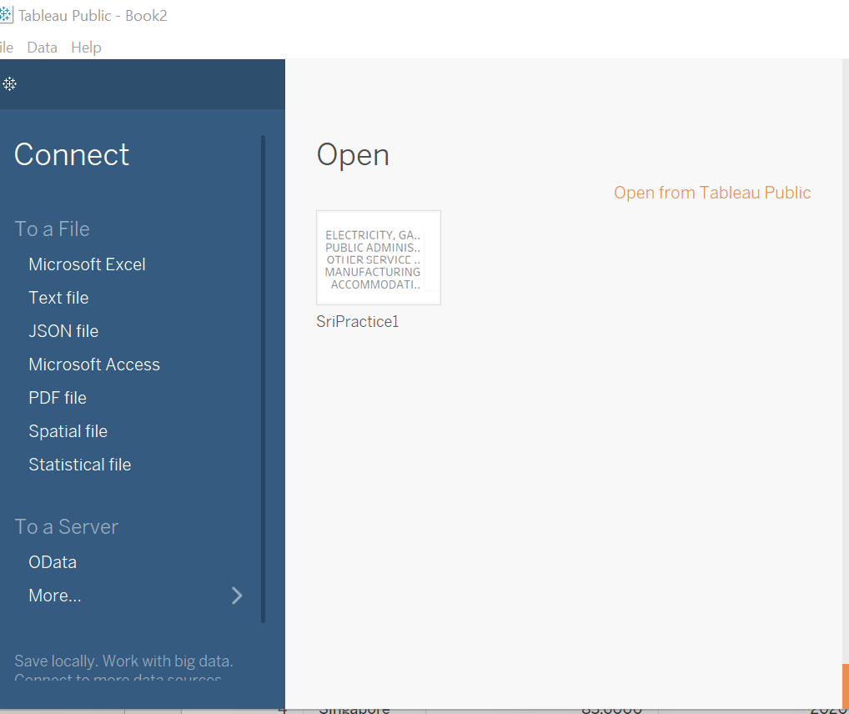

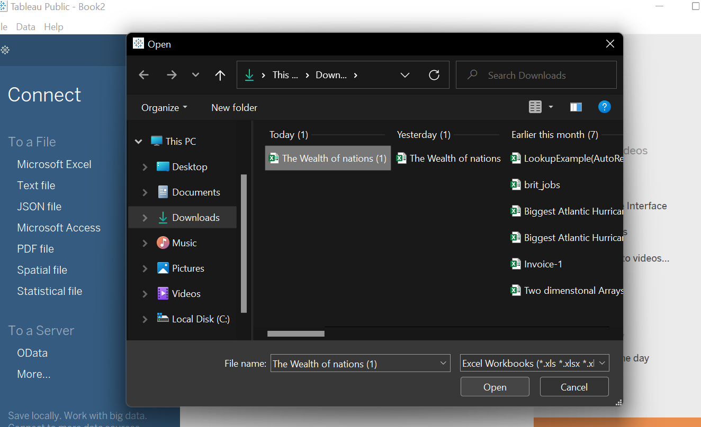

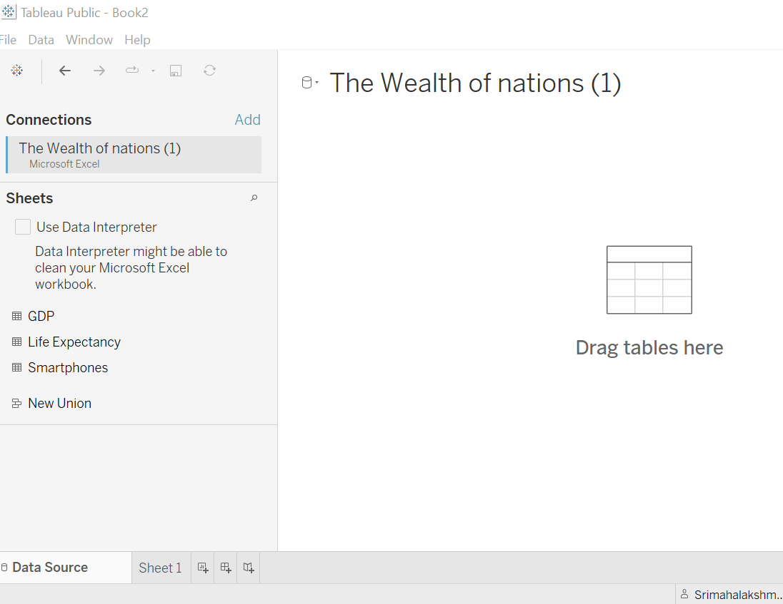

### Set relationships:

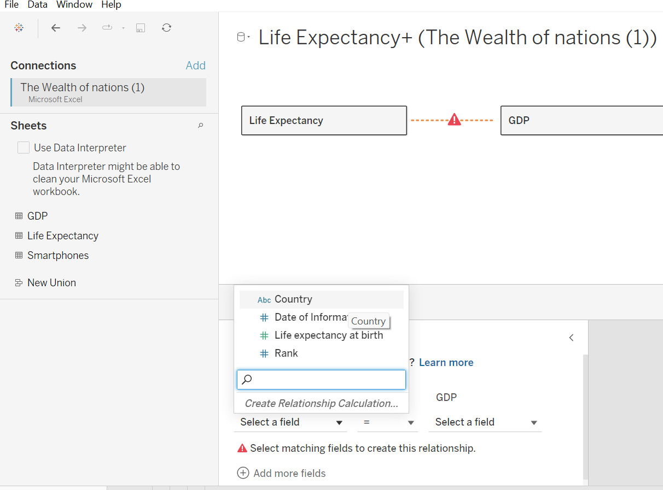

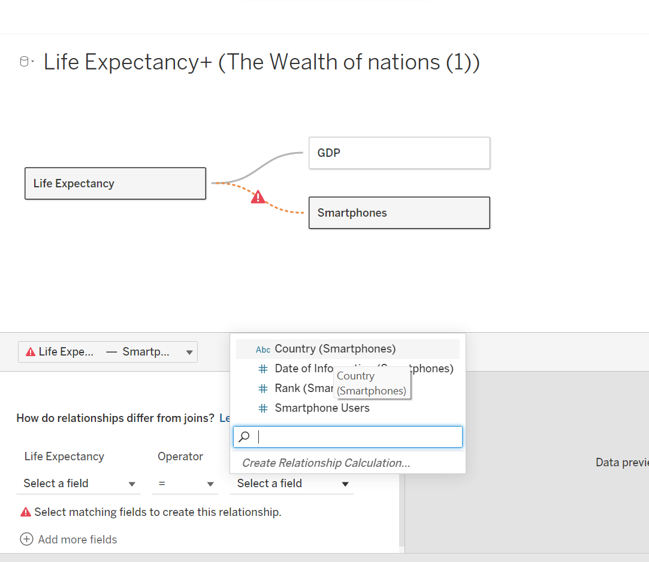

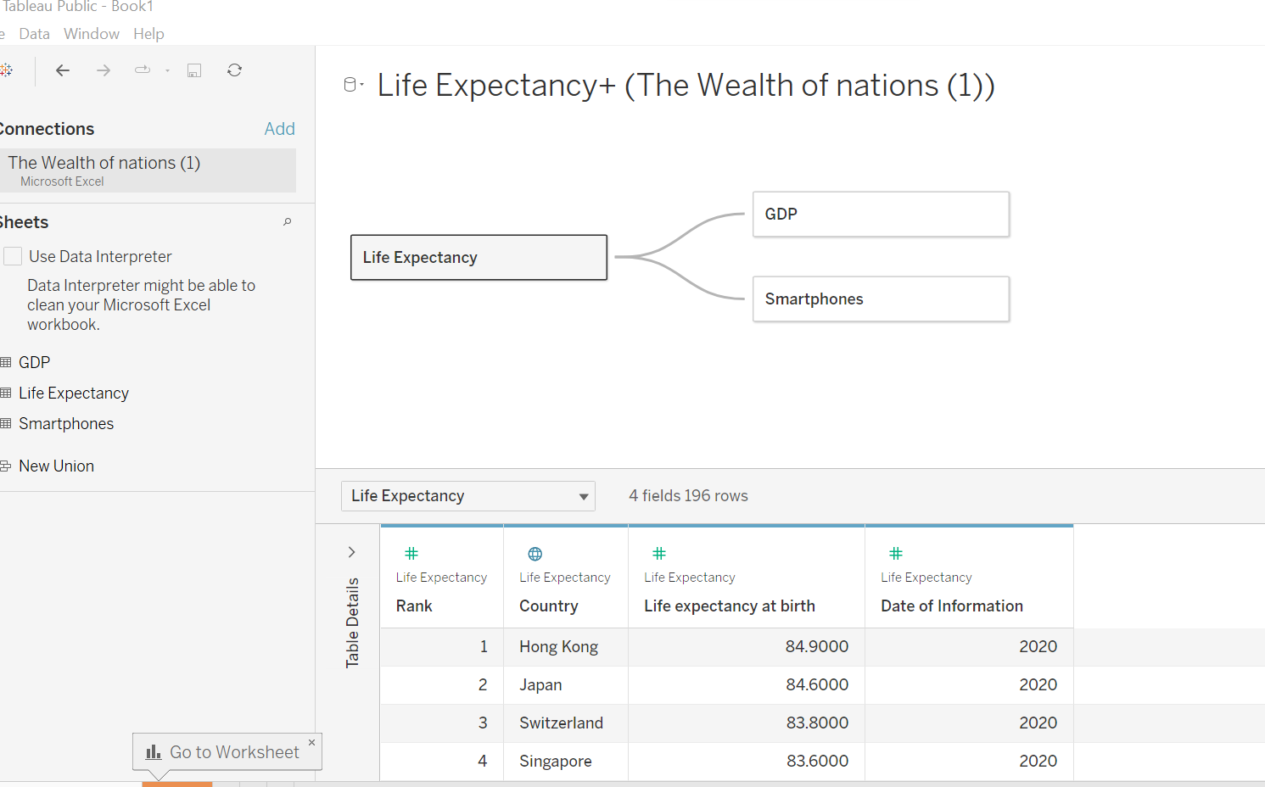

### Check data types.

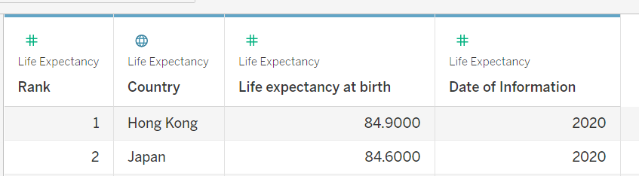

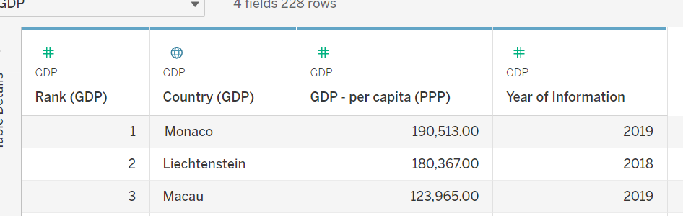

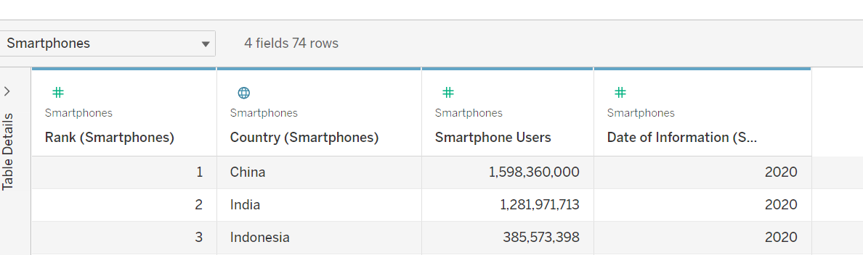

### Build charts

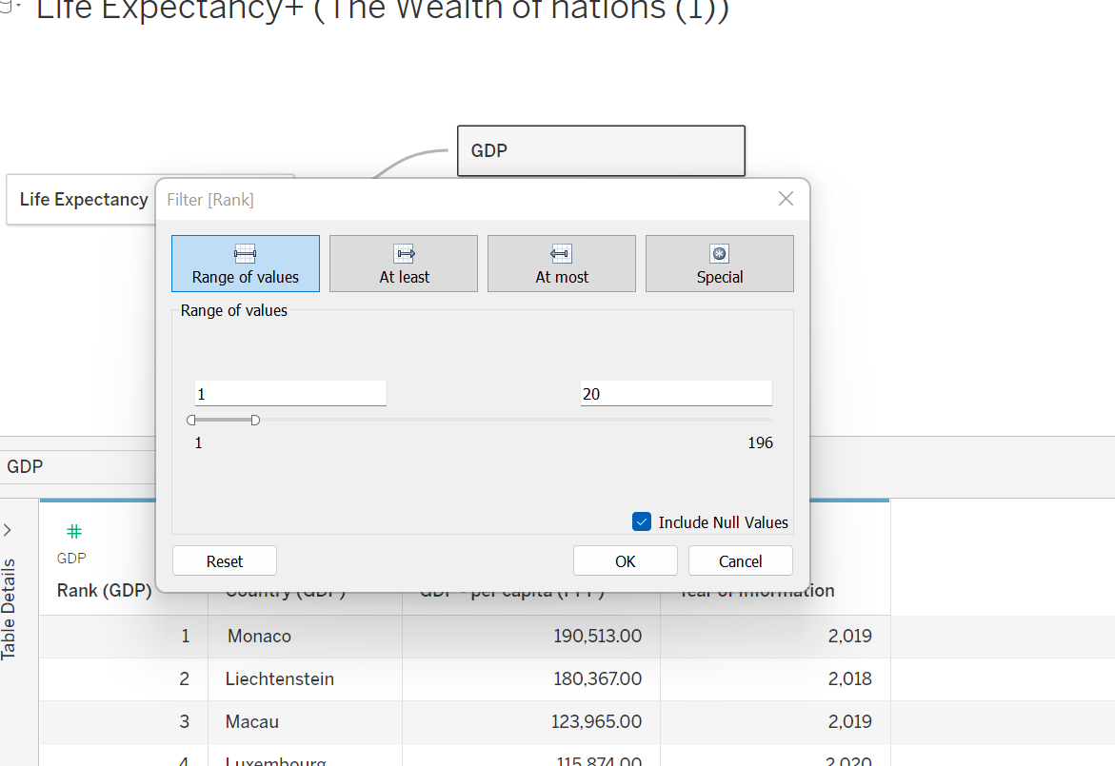

### **Chart1:**

#### Highest Rank in GDP Countries

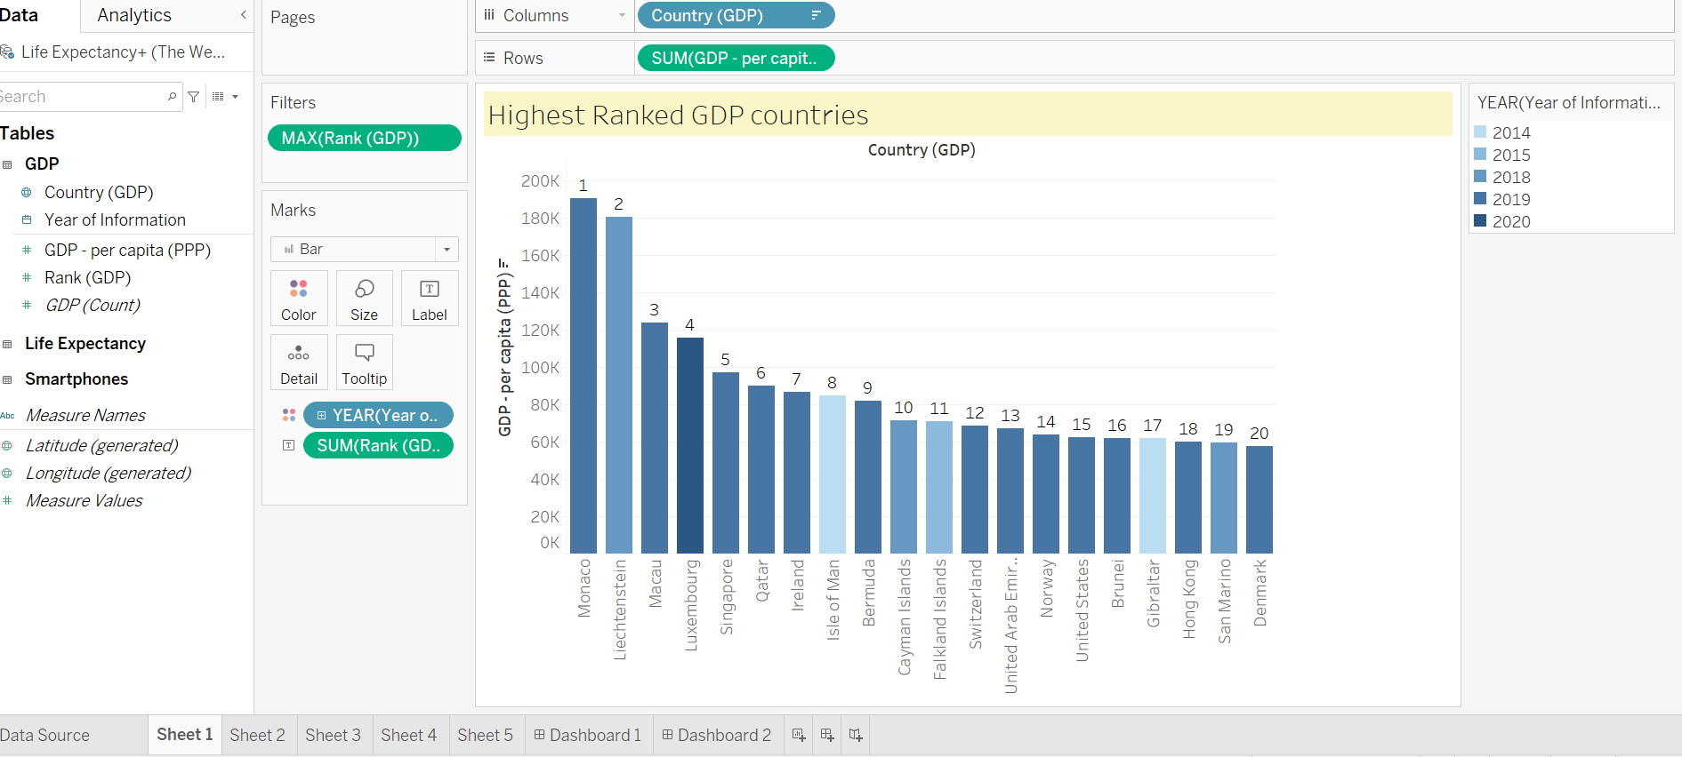

### **Chart2:**

#### Countries with Highest Life Expectancy at birth

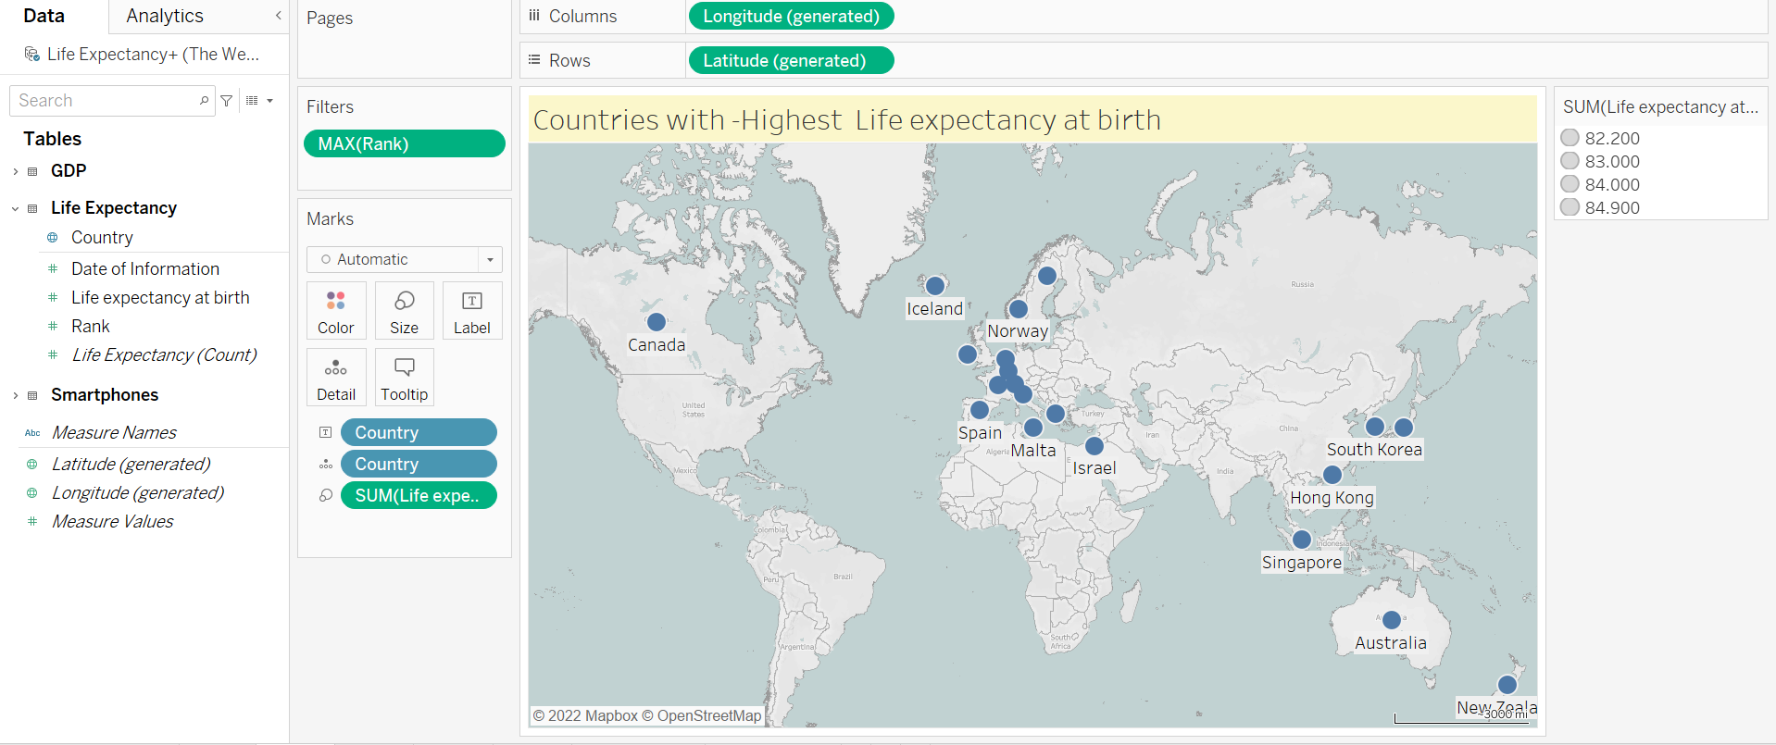

### **Chart3:**

#### Highest number of smartphones using Countries

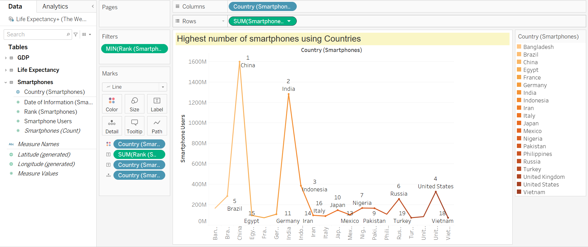

### **Chart4:**

#### Highest Smartphone Using Countries – Life Expectancy at Birth

#### 

### **Chart5:**

#### Highest smartphones Using Countries- GDP

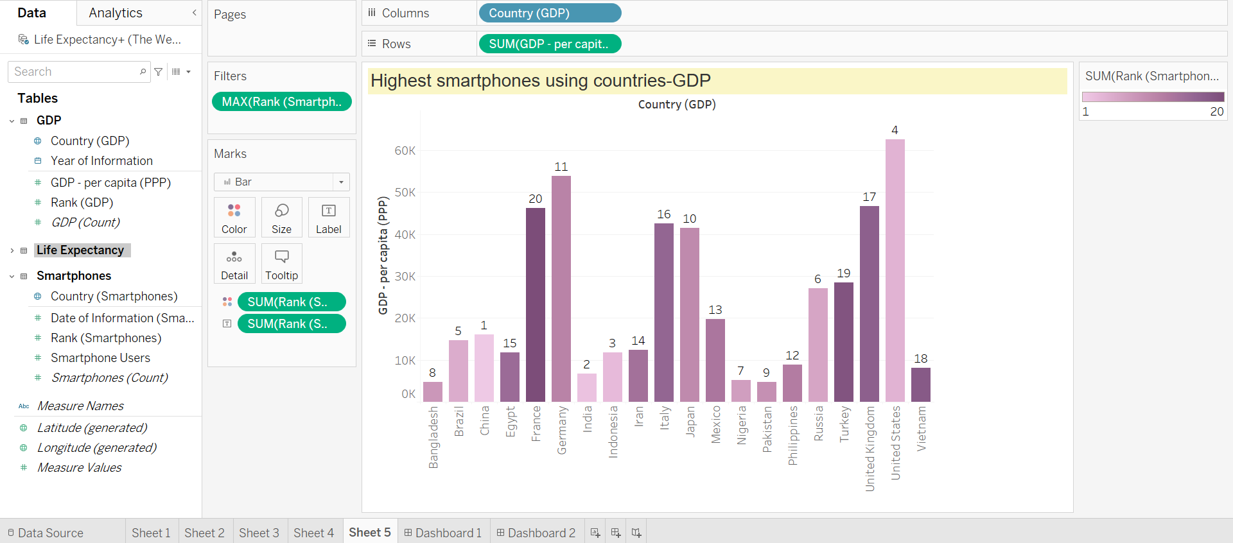

# **Dashboards**

### **Dashboard 1**

#### Nations GDP & Life Expectancy

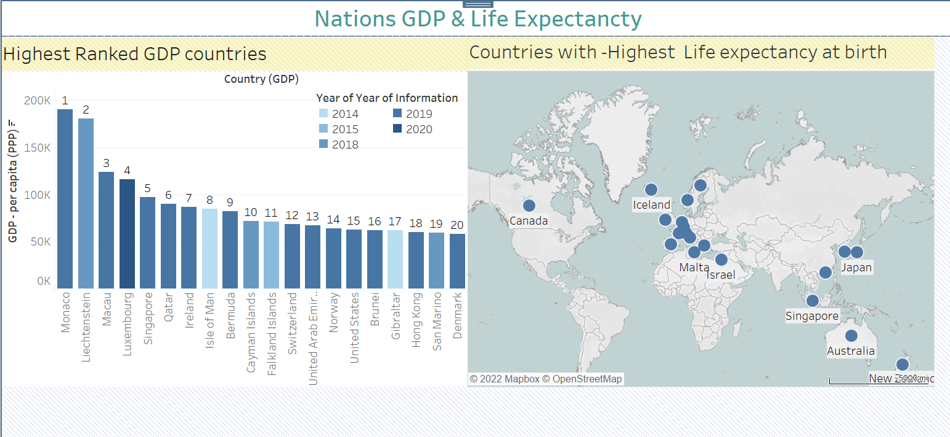

### Link For Dashboard 1:

<https://public.tableau.com/app/profile/srimahalakshmi.irrinki1404/viz/MyProjectDashboard1/Dashboard1?publish=yes>

### **Dashboard 2**

#### Highest Smartphone Using Countries- GDP & Life Expectancy

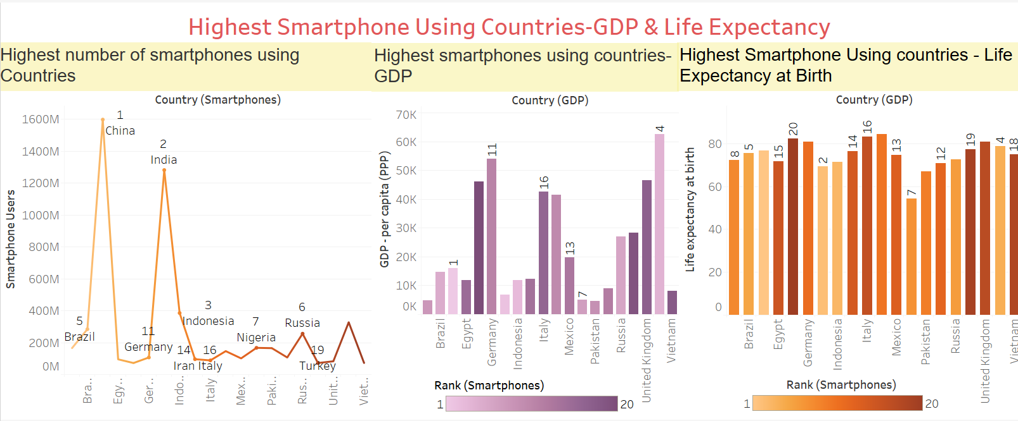

### Link For Dashboard 2:

<https://public.tableau.com/app/profile/srimahalakshmi.irrinki1404/viz/MyProjectDashboard1/Dashboard2?publish=yes>

**----------------------------------------------*********The End********---------------------------------------------------------**